1. INTRODUCTION
   1. Overview

It is well known that Co2 emission contribute the global warming and climate change which can significantly cause severe impacts on humans and the environment. Hence to reduce the terrific attack of Co2 emission we put forth this project.

* 1. Purpose

Human plays a major role in Co2 emission. Hence

this project gives an awareness to the humans and we can expect a disease free environment.

1. PROBLEM DEFINITION AND DESIGN THINKING

2.1 Empathy Map 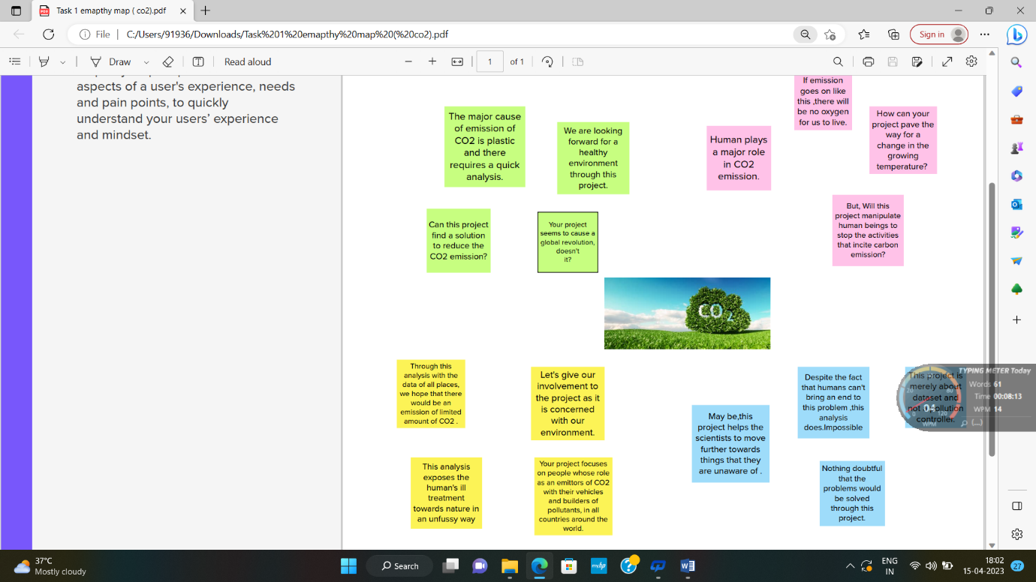

2.2 Ideation and brainstorming Map

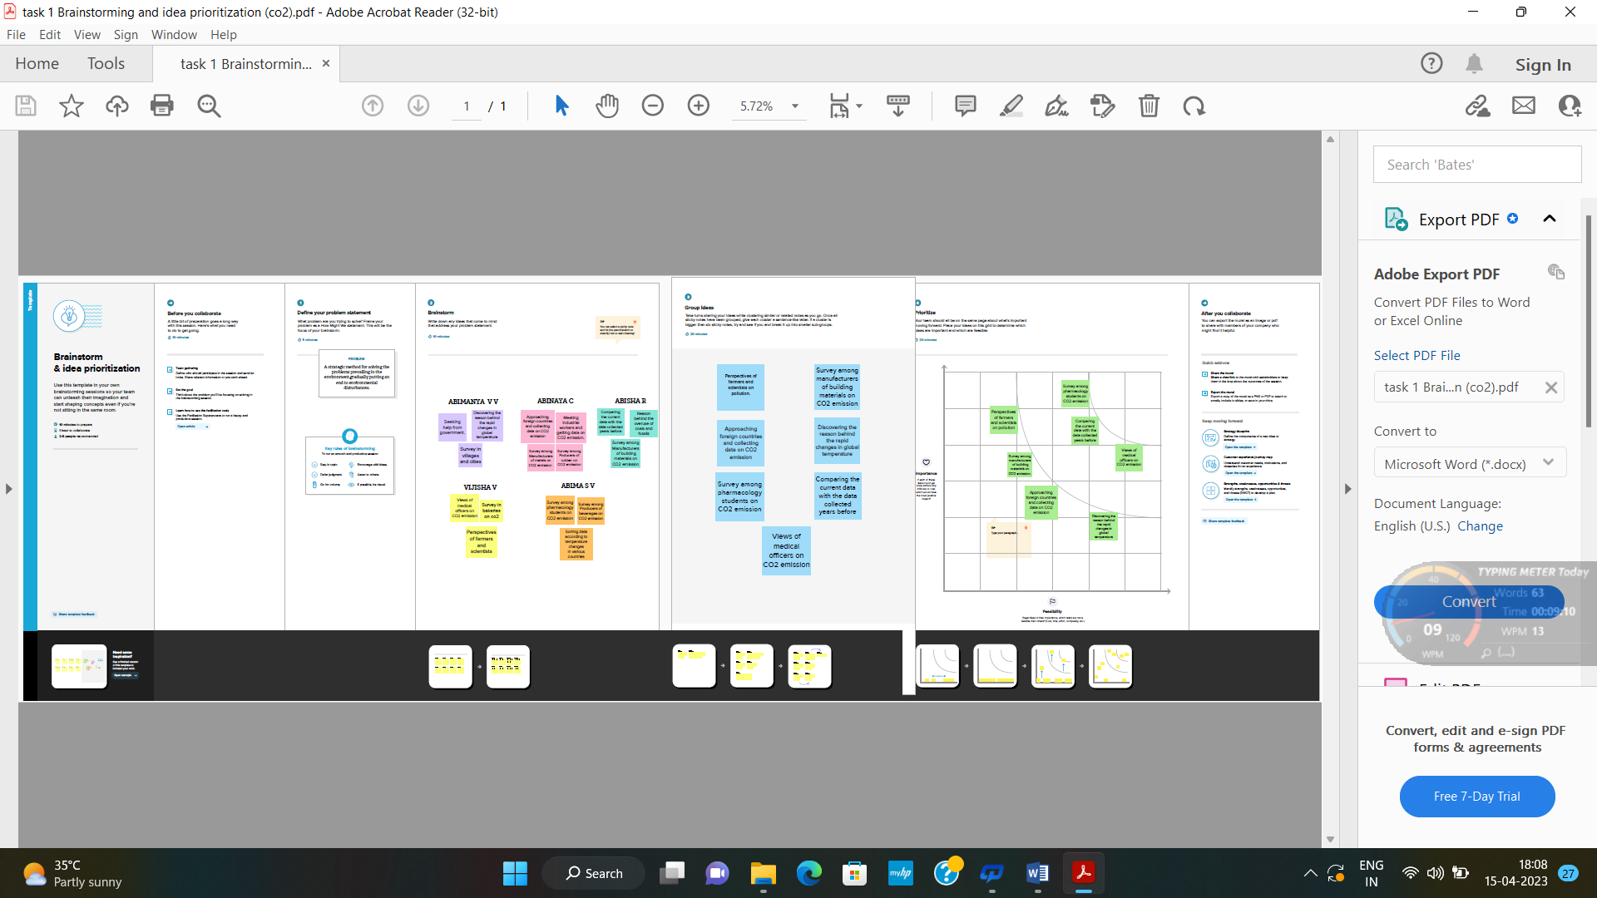

1. RESULT

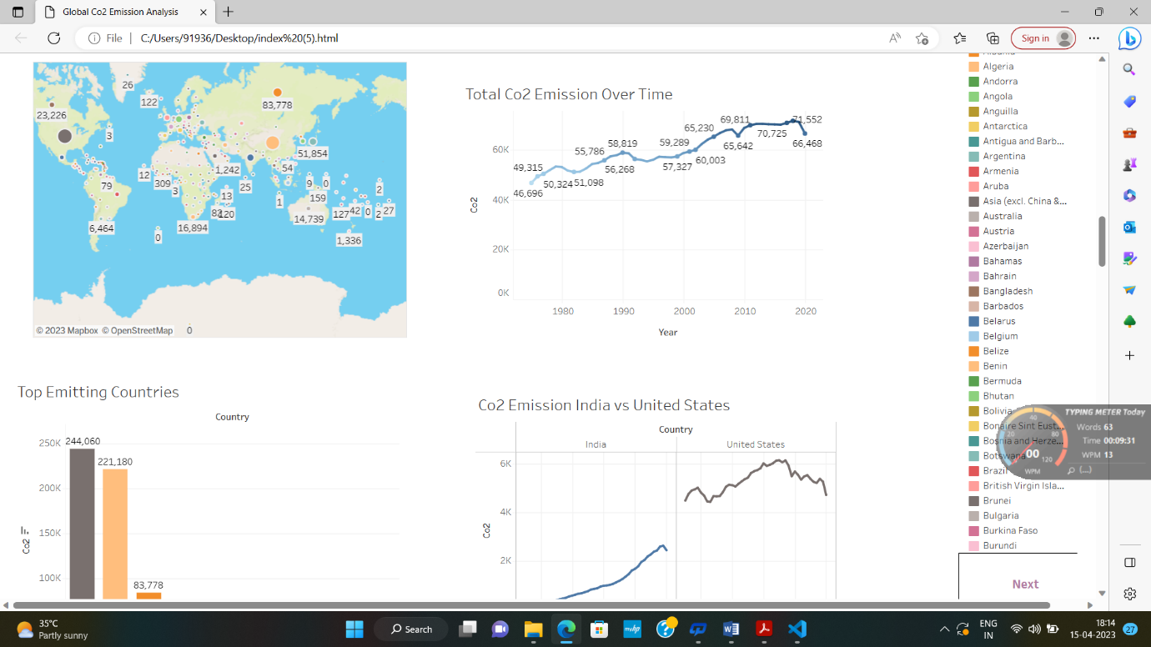

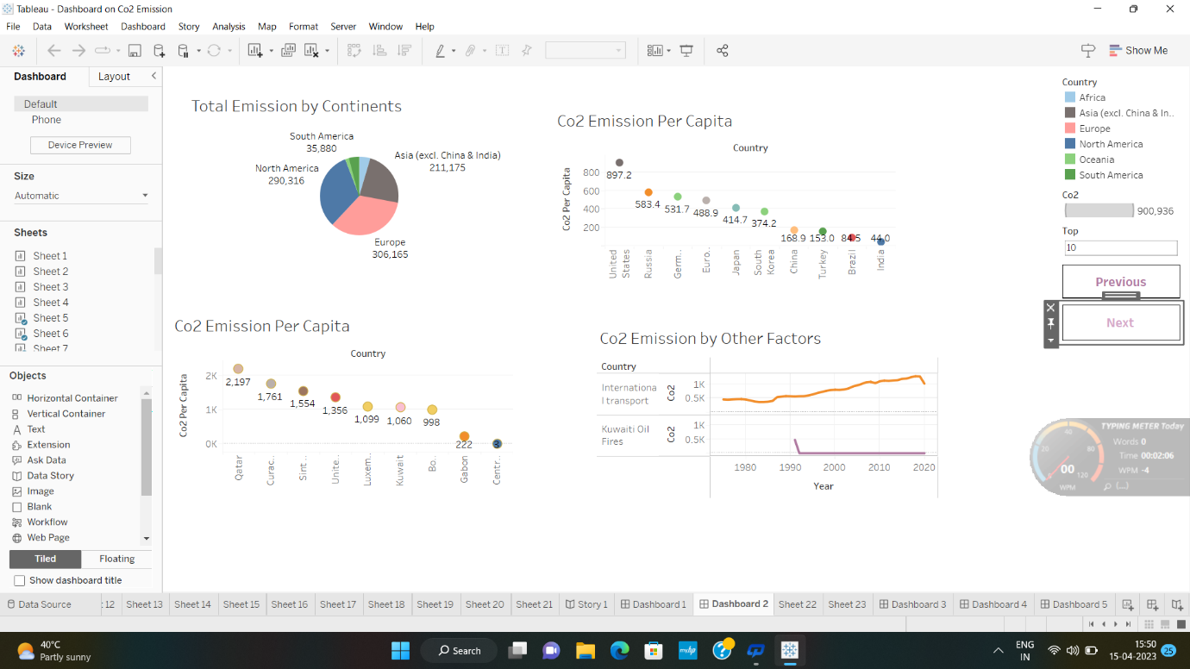

1. ADVANTAGES AND DISADVANTAGES

A major advantage through which people can be benefitted is that it makes people aware of the various factors responsible for Co2 emission as well as the various updated approaches to put an end to this problem. It gives job opportunities to many engineering students.

It suppresses many new technologies which would be a major disadvantage. It would be a backfire to the flourishing chemical producing countries and factories.

1. APPLICATIONS

It helps meteorologists and ecologists to study more about the current situation of environment through the data provided. It enables leaders, medical professionals to know the condition of their country thereby making their people to do accordingly.

1. CONCLUSION

Making this project well known to the world may expect production of materials that includes Co2 in a correct way.

Our project ensures a healthy environment to all the human beings.

1. FUTURE SCOPE

A disease free and pollution free environment can be made through this project. It also inspires the upcoming generations to do such projects which is beneficial for the world.